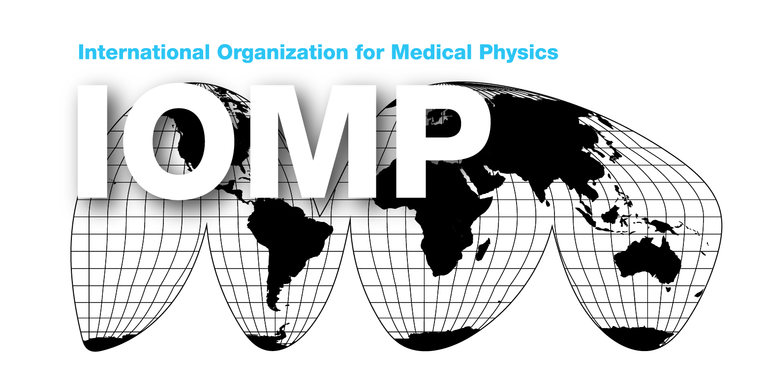
THE INTERNATIONAL ORGANIZATION FOR MEDICAL PHYSICS

ELECTION OF OFFICERS & CHAIRS: 2025-2028

INVITATION TO NOMINATE

The IOMP Council will elect the following Officers/Chairs by means of a ballot (via email). The new Officers/Chairs will assume office at the end of the General Assembly to be held during the World Congress on Medical Physics and Biomedical Engineering to be held in Adelaide, Australia, on 29 September – 4 October, 2025.

Post | Current Holder | Eligible for Re-election/Remarks
OFFICERS
President | John Damilakis | No.  President for 2022-2025.  He will be Past President.
Vice-President | Eva Bezak | No.  She will become President for 2025-2028. Nominations are invited for Vice-President.
Secretary-General | Magdalena Stoeva | Yes.  But nominations are invited.
Treasurer | Ibrahim Duhaini | No.  Nominations are invited.
COMMITTEE CHAIRS
Chair, Education and Training Committee (ETC) | Arun Chougule | No.  Nominations are invited.
Chair, Science Committee (SC) | M. Mahesh | Yes.  But nominations are invited.
Chair, Professional Relations Committee (PRC) | Simone Kodlulovich | Yes.  But nominations are invited.
Chair, Publications Committee (PC) | Francis Hasford | Yes  But nominations are invited.
Chair, Awards & Honours Committee (AHC) | Kwan Hoong Ng | Yes.  But nominations are invited.
Chair, Medical Physics World Board | Chai Hong Yeong | Yes.  But nominations are invited.

Nominations are invited from national and regional organizations (NMOs and ROs, including individuals) for any one or all of the above posts unless indicated. Nominating organization /person should send following information to the Secretary-General by 25th March 2025 (noon Central European Time), using the nomination form below, together with
- Nomination Form on page 3 below
- Biographical details (maximum 4 pages) and
- A personal statement (maximum 2 pages) by the nominee.

In his/her personal statement, nominee should include plans and visions for the post he/she is contesting for.

For each position and for each nominee, a separate form is needed. If a nominee is contesting for more than one position, a separate form is needed for each position.

All nominees should be known internationally for their distinction in the field, for their organizing ability, and for their ability to serve as Officers or Chairs for their respective terms of office.

The President can hold office for one term only and is not eligible for immediate re-election as an Officer. The Vice-President, who is the President-Elect, holds office for one term before taking office as President.

The Nominating Committee (NC) will consider nominations. The purpose of the NC is not to inhibit the delegates' choice of Officers and Chairs but to ensure that suitable nominations are made by the above or by the NC itself, that those nominated are willing to stand and, if there are too many nominations, to act as a preliminary filter.

Any question about the election procedure is to be sent to the Secretary-General (sg.iomp@gmail.com) or Vice-President (eva.bezak@adelaide.edu.au ) as chair of the Nominating Committee.

Prof Magdalena Stoeva
Secretary-General, IOMP
sg.iomp@gmail.com

NOMINATION FORM FOR ELECTION OF IOMP OFFICERS & CHAIRS OF COMMITTEES
CLOSING DATE: 25th March 2025
[12 noon Central European Time]

Post:

Nominee: Name: Title:

Address:

E-mail:

Proposer: Name: Title:

On behalf of * (Organisation)

Position*:

Brief address:

E-mail:

Seconder: Name: Title:

Position*:

E-mail:

* If applicable.

Comments:

The nominee has consented to having his/her name put forward: Yes/No
I attach biographical details.

Name: Date:
Include an image with your signature on the form and send by email to:
Dr. Magdalena Stoeva, Secretary-General, IOMP
sg.iomp@gmail.com

